How to Calculate & Review Mandatory Leave with Pay in HRIS
What is Mandatory leave with Pay? Mandatory Leave with Pay is based on your weekly standard hours of full-time employment (FTE) (37.5 or 40 hours a week). Part time employees are eligible for Mandatory Leave with Pay based on their part time weekly standard hours.

Example: if you work 18.75 hours a week, you are eligible for 18.75 hours of Mandatory Leave with Pay in a fiscal year.

Non-Continuous employees are required to take this leave between December 19th and January 5th on days set by the Employer.

Continuous employees can take this leave at any time during the fiscal year that is mutually accepted by the employee and the Employer. Mandatory Leave with Pay for continuous employees will be pro-rated based on the length of their employment during the fiscal year in their continuous position.

Examples:
Casual continuous employee (part time hours) on 5-month contract
- 18.75 hours/12 months = 1.5625 hours X 5 months = 7.8125 hours
- Casual continuous employee (full time hours) on 5-month contract
37.5 hours/12 months = 3.125 hours X 5 months = 15.625 hours
- Login to your HRIS (Peoplesoft), click Leave Details. | 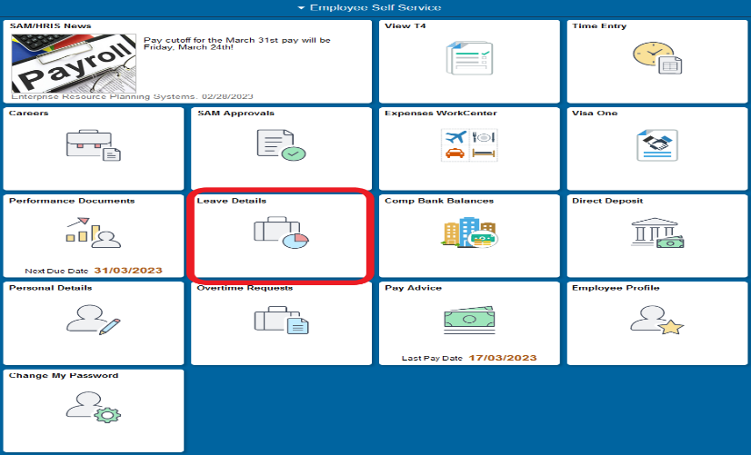
- A ‘search by’ banner will pop up, select Search, and choose your record if applicable. | 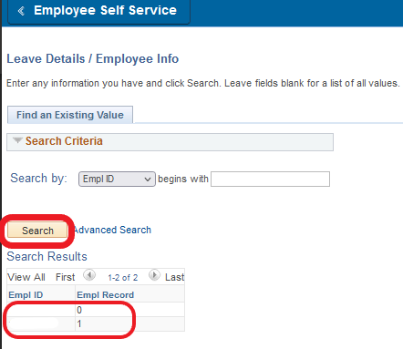
- Click the small arrow icon on the right end of the taskbar to reveal additional tabs. | 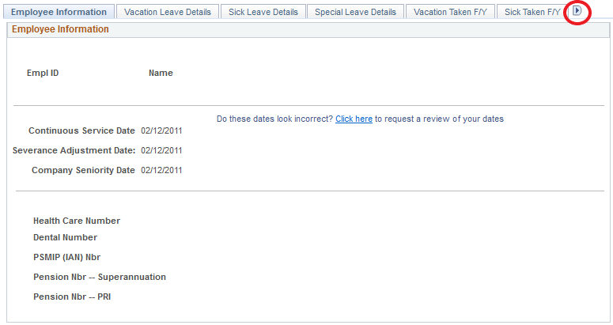
- Click the Mandatory Leave Taken F/Y on the right end of the taskbar to review Mandatory Leave taken and paid out. If you are non-continuous, this is generally blank like this example. | 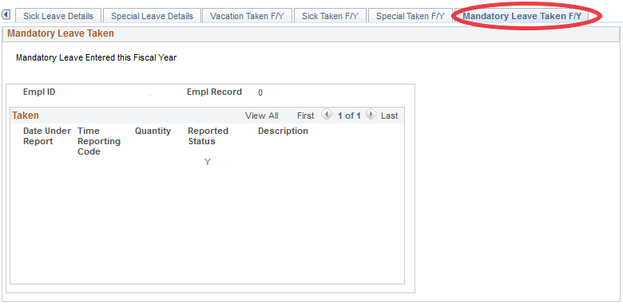
- This is an example of a shift worker with combinations of leave taken and payouts. | 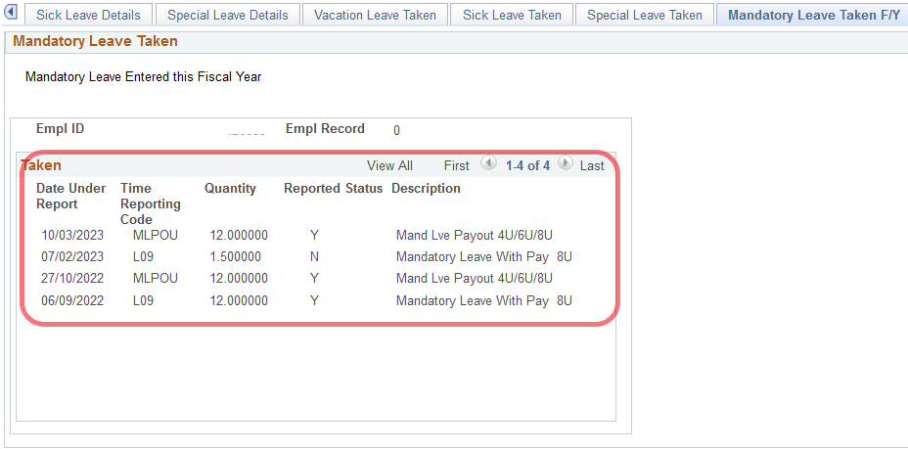
The HRIS (Human Resources Information System) Help Desk is the primary point of contact for all GNWT employees. If you have a question, please contact the Help Desk.
The Help Desk is open 8:30 a.m. to 5:00 p.m. Monday to Friday.
Phone: 1-867-678-6625 / 1-866-475-8162 (toll-free) Email: HRHelpDesk@gov.nt.ca

